**Assignment 15.1**

**1.Write a simple program that shows inheritance in scala**

1. **source code**
2. **class** Employee{
3. **var** salary:Float = 10000
4. }

**class** Programmer **extends** Employee{

1. **var** bonus:**Int** = 5000
2. println("Salary = "+salary)
3. println("Bonus = "+bonus)
4. }
5. **object** MainObject{
6. **def** main(args:Array[String]){
7. **new** Programmer()
8. }
9. }

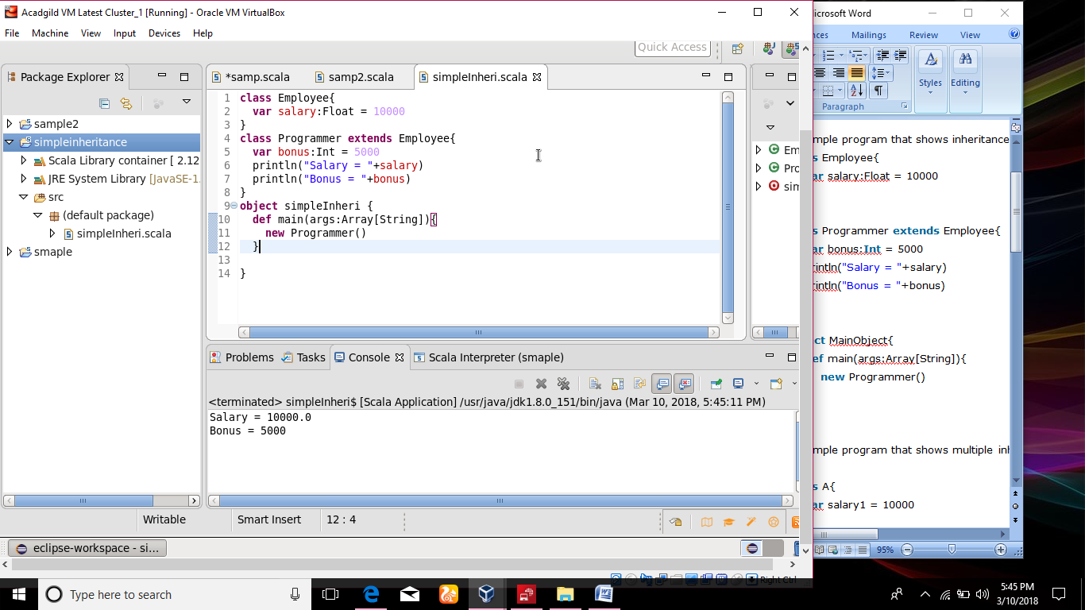

**2.Write a simple program that shows multiple inheritance in scala**

**Source code**

1. **class** A{
2. **var** salary1 = 10000
3. }
4. **class** B **extends** A{
5. **var** salary2 = 20000
6. }
7. **class** C **extends** B{
8. **def** show(){
9. println("salary1 = "+salary1)
10. println("salary2 = "+salary2)
11. }
12. }
13. **object** MainObject{
14. **def** main(args:Array[String]){
15. **var** c = **new** C()
16. c.show()
17. } }

